NTU Recruitment Day App

Project proposal

n0683858: Hamid Mujtaba

2019

Contents

**Executive Summary** 2

**Software and Hardware Development options** 3

**Usability and Guidelines** 3

**Requirements and Constraints** 3

**Proposed Idea and Impact** 3

**App Features** 3

**Evaluation of Paper prototype** 4

**Appendices** 4

**References** 4

# **Executive Summary**

The proposed application for the project is a mobile application for recruitment fair hosted by NTU for their students, where various companies will come and advertise job/placement opportunities. This allows the students to interact with different companies and gather more information on the type of job they are interested in. Currently, there is no platform available to the students where they can look into the companies coming beforehand or know which companies will be attending the Job/Recruitment fair, thus they cannot visit all of them on the day. Another issue students face is they do not know the location of the companies. This is very true, especially for students in the first year as they are un familiar with the campus, thus they may struggle to get around to locate the company they want to inquire about. In addition to this, there is no way to find out if the companies present offer placement opportunities or just job opportunities, as well as if they offer graduate schemes.

The proposed application will tackle this issue by providing the solution to all problems mentioned. The application will include a feature for the students to view all the companies that will be attending the recruitment fair. They will be able to filter the companies according to the job/opportunities they provide, so for example, if a Software Engineering student wanted to look for all the companies that will be coming to the recruitment fair, offering job/placements related to programming, they will be able to do so by using the dropdown option provided at the top. The options given would categorise the companies into their respective fields and by the jobs being provided, such as, IT, Business, Sports, Science etc. All the programming related courses, i.e. Computer Science, Software Engineering etc will be grouped under ‘IT’ and all sport related courses will be under ‘Sports’. The application will then display all the companies/opportunities related to the selected category. There will also be a map feature implemented in the application to allow students to see where they currently are on the campus. In addition to this, when they click on a job opportunity, there will be a button which will show the location of the company providing that opportunity on the map when clicked. They can also add the opportunities to ‘Bookmarks’ so they don’t lose track of the companies/opportunities they were interested in and would like to inquire about on the day. The students will be able to use a QR scanner to register their attendance. They will also have the option to “apply” for the job opportunity from within the application which will give them instructions on how to apply. The students will be able to change the campus map from settings depending on which campus the event is being held in.

The application will be managed by the admins. They will have a sperate interface compared to normal users (admin dashboard). They will be able to manage all user (admin and students), delete users, add new users (admin and students) and edit users. They will also be able to add opportunities being offered by different companies.

# **Software and Hardware Development options**

This proposed project will a mobile application for phones ran on android platform. The reason for choosing to do the project as a mobile application because it will make it easier for the user as they will always have all that information available to them on the go. Mobile phones are small, convenient and don’t weigh much so they can easily fit in pockets or bags; compared to desktop which the users can’t carry with them, or tablets that weigh a lot and have big (screen) sizes so can be difficult to fit in the bag or pockets. It allows users to make notes and set reminders which can be very helpful to make sure everything is going according to the schedule and the user doesn’t miss or lose track any tasks. Mobile phones allow you to capture photos and videos using the camera which is something not possible for desktop. Users can then instantly share them to social media platform, send to friends/family through messages/emails or share with other users through Bluetooth. Bluetooth is a feature available in mobile phones which is used for linking electronic devices together and allowing them to communicate with each other, allowing to send, receive small files. However, it only works when the target mobile phone is relatively close by (within the range of user’s phone). Mobile phones allow users to communicate with other users through text messages which is not restricted by location using the SMS functionality. Mobile phones are the future for technology, and have every functionality and features available on desktop, tablets and even hand-held gaming devices such as Nintendo. Mobile phone also allows users to install and play games which are usually available on other platforms such as Nintendo, PSP etc by using emulators. There are also games available exclusive to mobile platforms. Mobile phones can be great for organizing and managing the users schedule with the calendar feature. It will send notification/alerts to remind users when its time to perform certain tasks or if its time for a certain event. All mobile phones come with GPS feature which is used by applications for location tracking and displaying maps. It is a useful functionality which allow apps such as Google Maps to help us with directions to our destination. In addition to this, it also gives live updates on your location and surroundings such as roadworks, accidents or nearly facilities such as restaurants, hotels and stadiums etc. Users can now do online banking and shopping using their phones. They can store their card details inside their mobile phones and by using the NFC (Near field Communication which allows data transfer between devices) tags, they can use their phones to pay for groceries etc instead of using their bank card.

The project will aim to target Android platform instead of iPhone (IOS). The main reason for this is because according to the statistics, Android share 87.0% of the market while IOS shares only 13.0% (Melissa 2019). Android is an open-source linux-based operating system developed by google. Android OS isn’t just used for mobile phones, but for other devices too such as watches, fridges, car stereo etc (Marziah 2019). Compared to IOS, there are a variety of mobile phone companies which use Android as their OS where as only iPhone use IOS for their phones. This shows that the project will be able to influence a large number of audiences, compared to IOS and more people will have access to it. In addition to this, to develop mobile applications, you have to pay for their IDE whereas android is free.

# **Usability and Guidelines**

(any accessibility issues? E.g.is this app for the elderly?, does it require a bigger font? e.g. is it for children? Does it need to be colourful? Which design guidelines are you following (e.g. Google design guidelines, amazon Design guidelines, or provide an explanation of how the chosen colour, style, themes, materials are relevant). More information about Google/Apple material design and guidelines are provided in Week5 section.

The target audience for this project will be university students who are interesting in going to the recruitment fair to inquire about different job/placement opportunities and talk to companies to find out more information. The font will be big and bold for the main headings such as opportunity title so that it stands out from the rest of the text and easier to read for the user. All the headings will be bold to make it stand out but will be different sizes depending on how important the information they’re trying to highlight is. The navigation bar will be placed on the top where the user will have to click the ‘burger button’ to display it. It will contain icons next to the options provided to make it look more professional and easier to tell the user what the option given is about using very few words. The buttons will a different colour so the user can easily identify them as they will stand out and not confuse them with regular text. The

# **Requirements and Constraints**

Extract requirements make use of the Persona template provided in Week5 section to help in extracting the requirements and needs. Are there any constraints to consider? Does the application require regular maintenance (e.g. database and network support)?, or external hardware that needs to be replaced (e.g. beacons or NFC tags need to be replaced or updated yearly..etc.), another example ( the app might work outdoor but not indoor because of GPS signals).

# **Proposed Idea and Impact**

(why this app?, what is the impact on the business (e.g. will it increase profit? More customers? Better management system?).

# **App Features**

What are the main technical application features (make use of the features template provided in Week5), e.g. login page, connection to the database, video gallery, interactive maps..etc.).

# **Evaluation of Paper prototype**

(2 users/functionality testing): Ask two people to try your paper prototype in terms of functionality and the suitability of resources/widgets, and ask them for suggestions to improve the design.

* Admin creating users? How will they get their password to login?
* How to know if they offer placements
* Recruitment fair info (next recruitment fair)

# **Appendices**

* 1. Personas (Template provided in Week5 section): Depending on your application, if you have more than one user type then you need more than one persona, e.g. if the application aims at the employees and staff then you need two personas 1)one for the manager 2) and one for the employees.
  2. Paper Prototype (Minimal Viable Product) after testing.

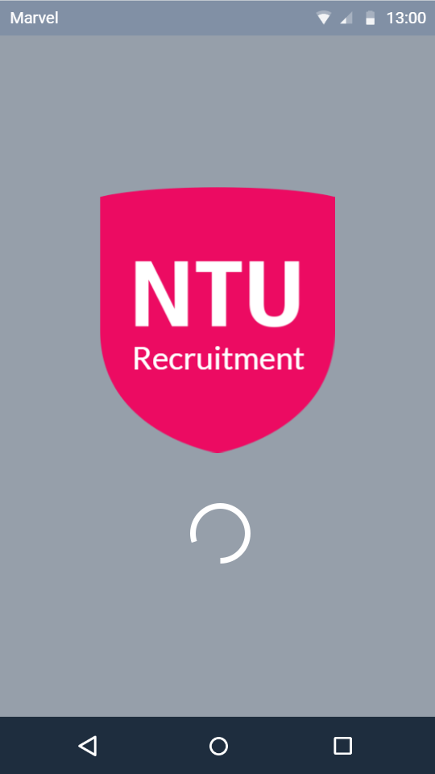 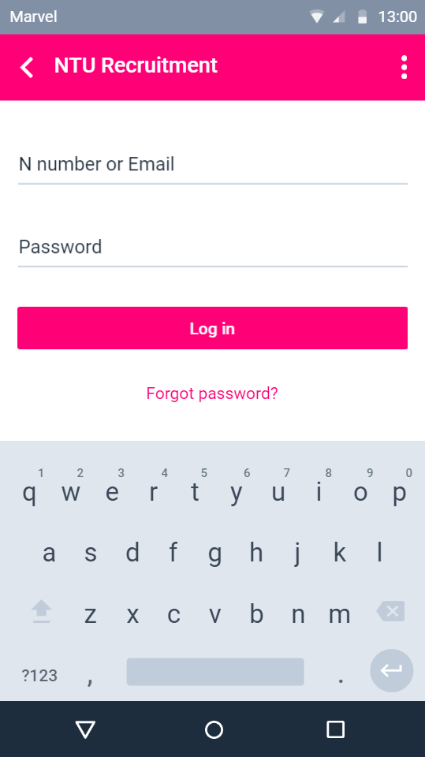 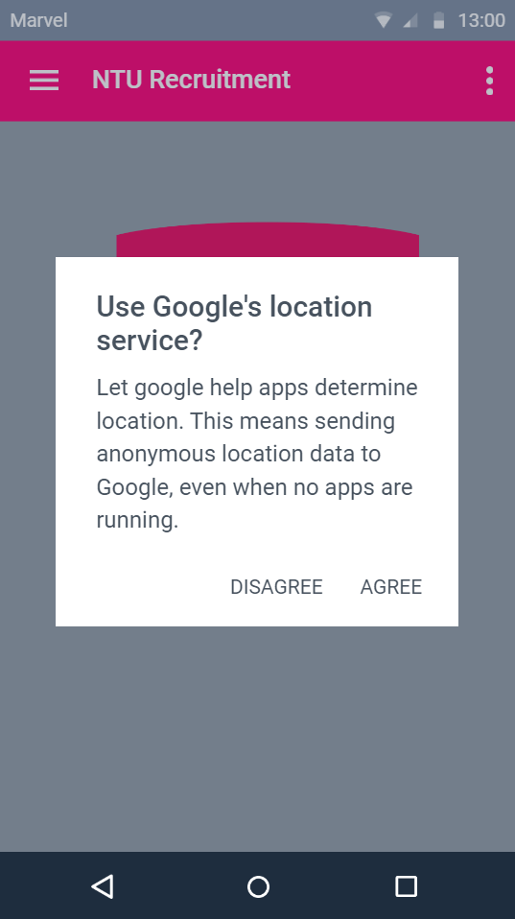

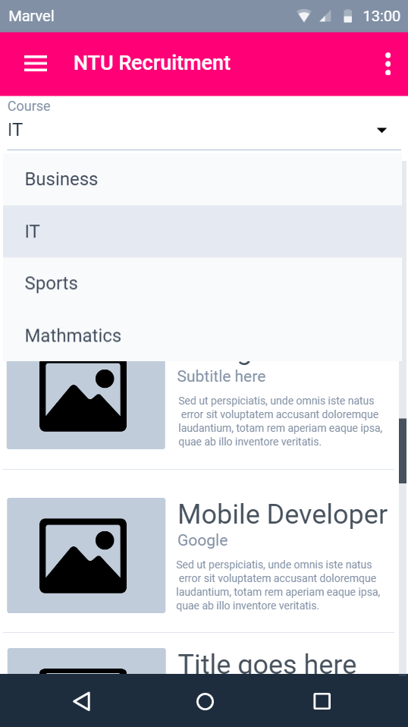 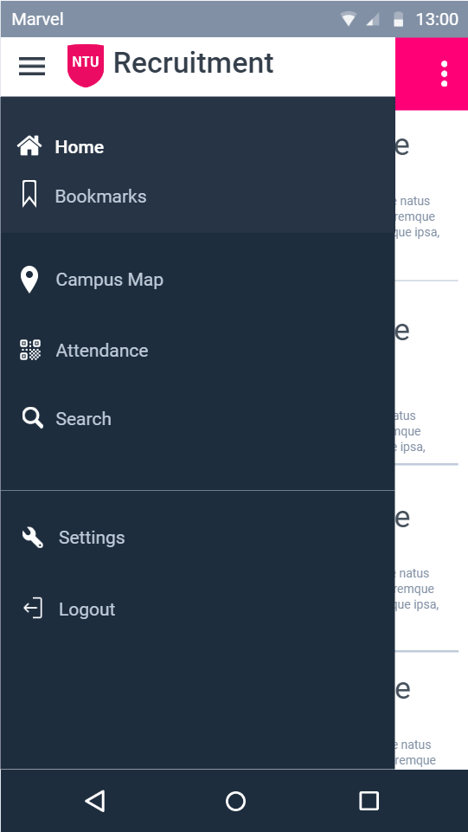 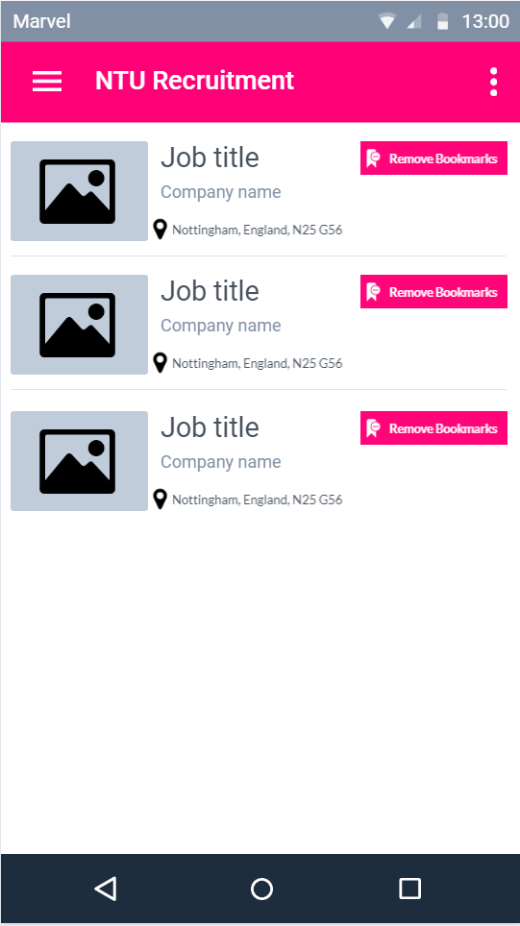

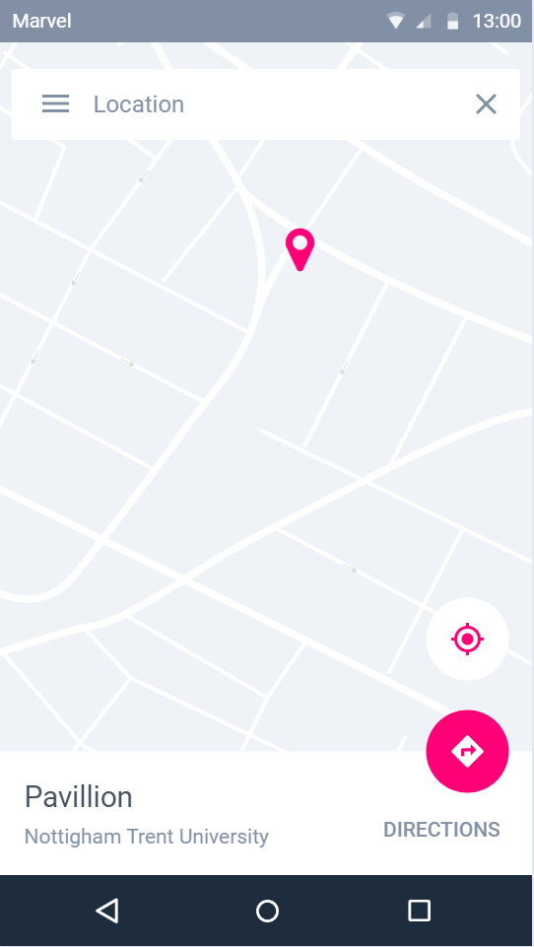 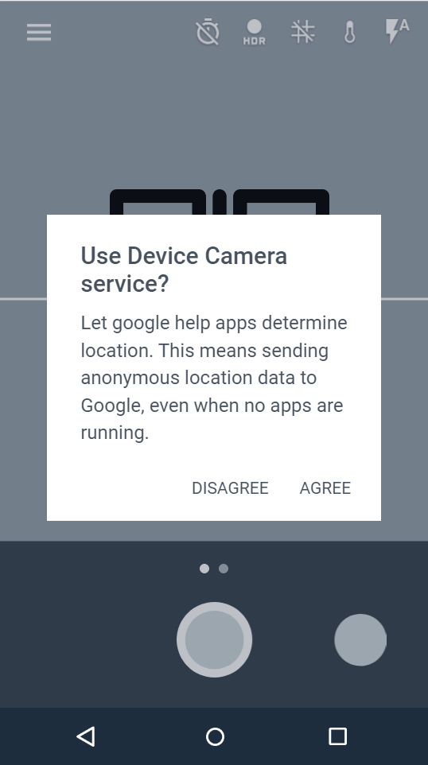 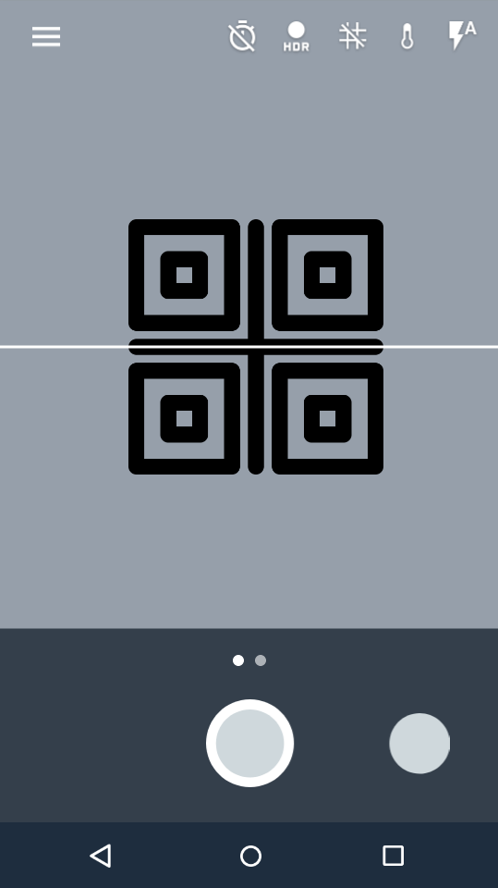

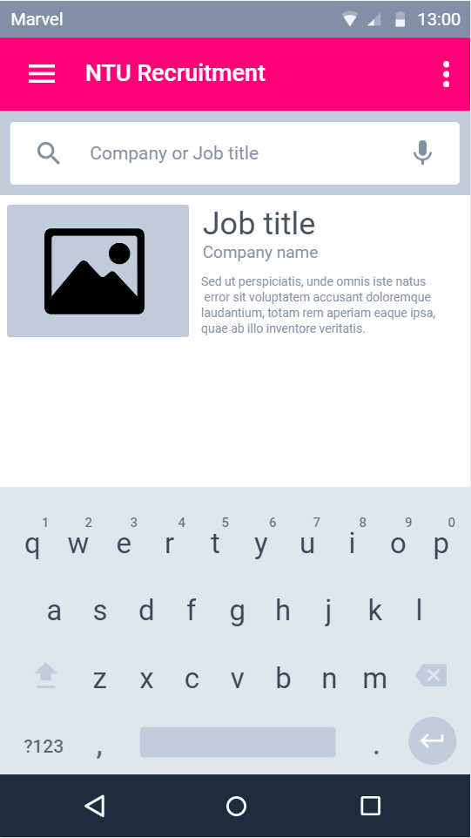 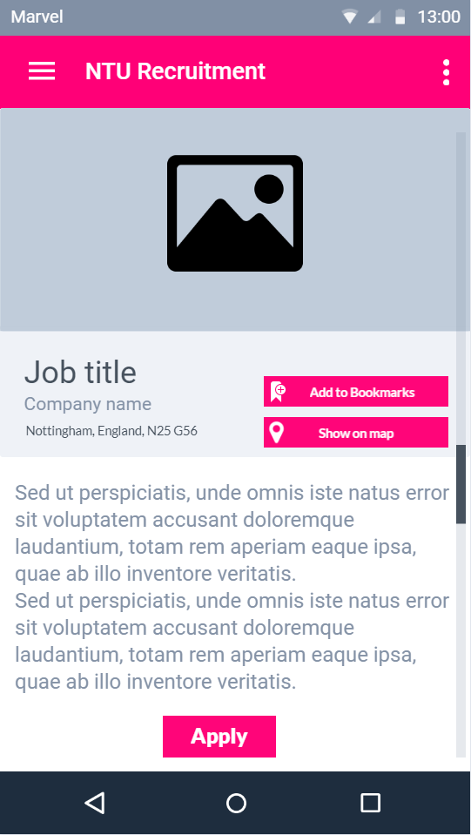 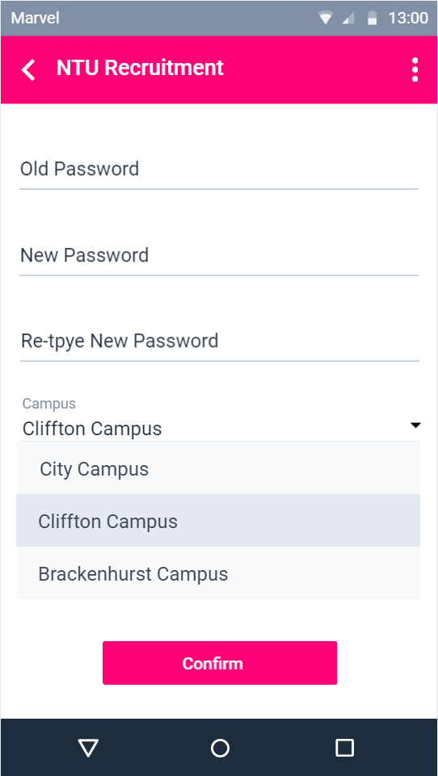

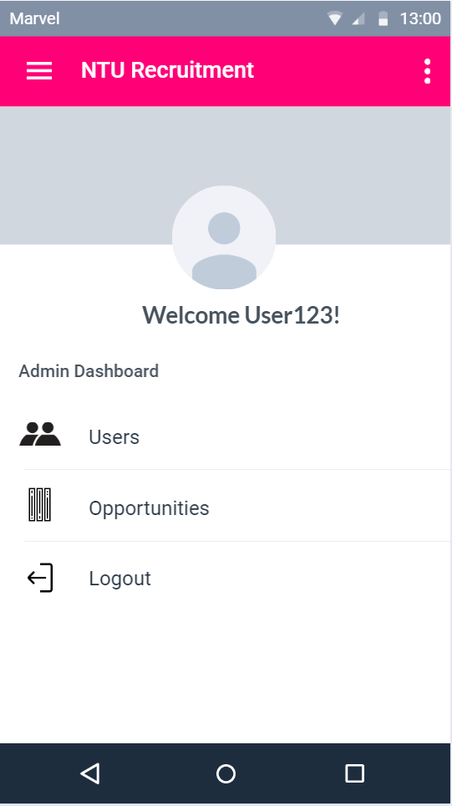 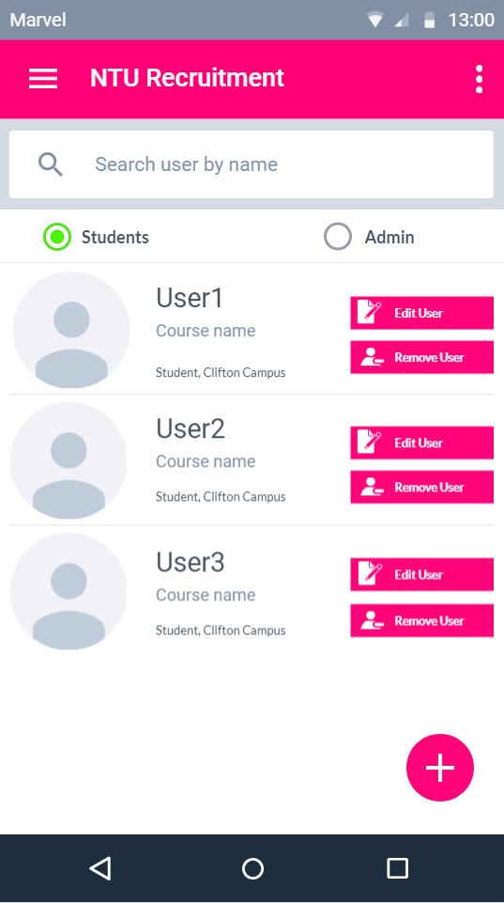 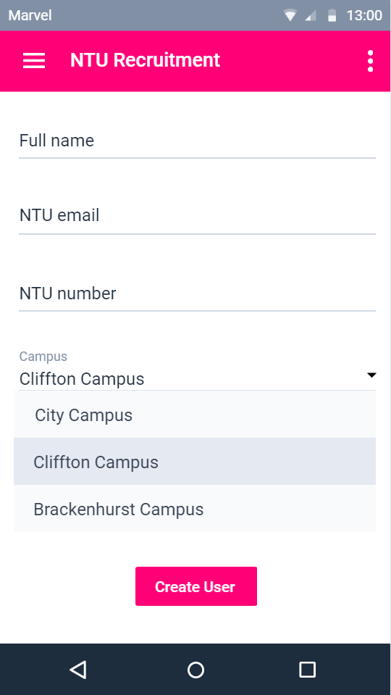

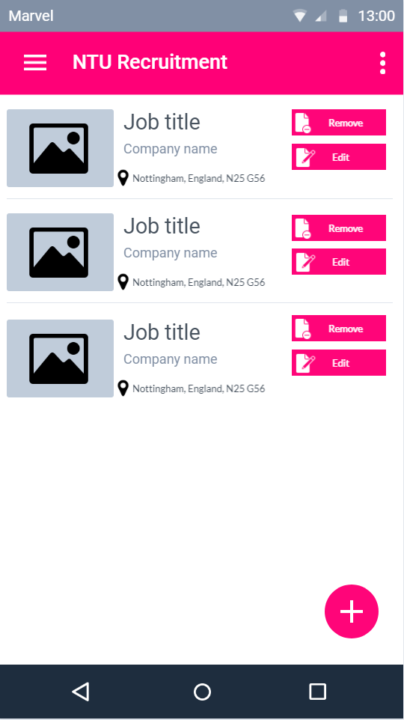 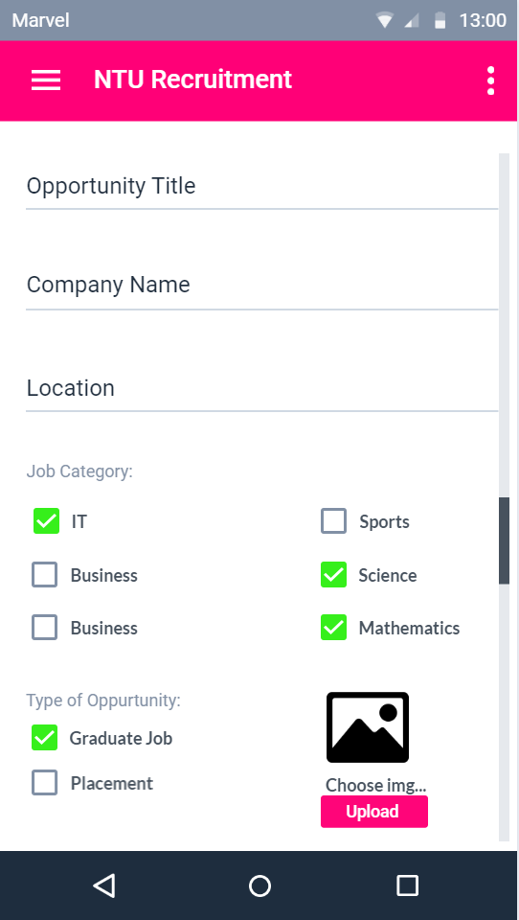 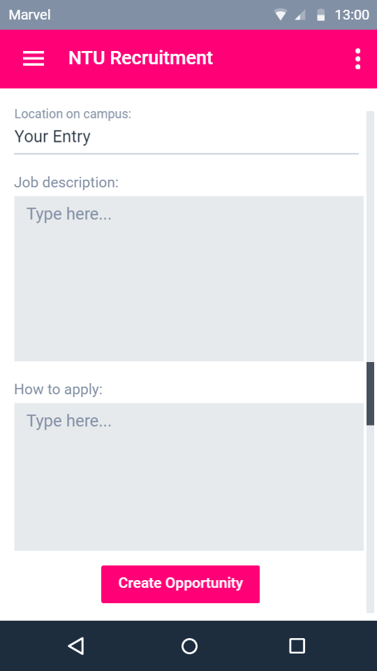

# **References**

Chau Melissa, Reith Ryan. 2019. Smartphone Market Share. [Online]. [28 November 2019]. Available from: https://www.idc.com/promo/smartphone-market-share/os

Marziah karch. 2019. What Is Android?. [Online]. [28 November 2019]. Available from: https://www.lifewire.com/what-is-google-android-1616887

Google. NA. Material Design. [Online]. [28 November 2019]. Available from: https://material.io/design/